**Field tests of a novel fin-mounted Fastloc GPS tag for small cetaceans..**

Reny B. Tyson Moore1, Kenady Wilson2, Ed Bryant2, Matt Rutishauser2, Aaron Barleycorn1, and Randall S. Wells1

*1Chicago Zoological Society’s Sarasota Dolphin Research Program, c/o Mote Marine Laboratory, 1600 Ken Thompson Parkway, Sarasota, FL 34236, USA*

*2Wildlife Computers. 8310 154th Ave NE. Suite 150. Redmond, WA 98250 USA*

Target Journal: Methods in Ecology and Evolution

Guidelines:

* Single column, double line spaced
* Within the word count (6000-7000 words for Standard Articles, 3000 words for Applications)
* Continuous line and page numbering throughout
* Clearly defined manuscript structure as standard: Author details, Abstract (must be numbered according to Manuscript Specifications), Keywords, Introduction, Materials and Methods, Results, Discussion, Figures and Tables with captions
* Figures and Tables can be embedded within the text where referenced to facilitate reviewing
* Statement of where you intend to archive your data

**Abstract**

Focus on:

* Accuracy of locations with two different location processing systems
  + First time done in the field for small cetaceans
* Tag performance (maybe) – not too many field tests with continued & post monitoring
  + How long did they record data
  + Issues with sending signals?
  + Physical tag life
  + Animal after tag gone

**Introduction**

The development of FastLoc® GPS technology allows GPS signals to be transmitted in fractions of a second, enabling their use with marine mammals that surface much faster than traditional GPS systems require for transmission of signals.

While satellite-linked tags have been available for use with marine mammals for several decades, tags that incorporate GPS technology have been hard to develop for these animals because the GPS signal requires exposure at the surface for longer periods of time than an animal typically breathes. Location data from GPS tags is more precise than location data from satellite tags so the ability to incorporate GPS into tags would open new doors for research opportunities on small cetaceans, such as bottlenose dolphins, pilot whales, and false killer whales. FastLoc® Location Technology was recently developed to deal with this problem, and is able to obtain GPS data in fractions of a second. This technology thus represents an exciting development that may allow researchers to use the power of GPS for tracking dolphins and porpoises in a more accurate and precise way, for the very first time.

In a SPOT-F tag, typically, Fastloc GPS is used to generate location data and Argos uplinks are used to transmit the data snapshots. When the tag is out of the water and specified sampling conditions are met, depending upon the number of satellites visible to the tag, the tag will be able to acquire and process a GPS location onboard the tag. A Fast-GPS acquisition is considered successful if 4 or more satellites are identified in the Fast-GPS snapshot. Any acquired positions will be stored on the tag and transmitted through Argos during subsequent periods at the surface.

Fastloc GPS acquisitions are fast (sub-second) and the onboard processing takes 12 seconds and continues after the animal has submerged. Transmissions to Argos are primarily for sending data messages (the Fastloc GPS locations, and temperature and behavior data products depending upon tag programming) but you may occasionally get Argos doppler locations along with the transmitted data products. Fastloc GPS locations are further processed in the Wildlife Computers portal once they are uploaded so you can get movement "tracks".

These tags represent the first fin-mounted tags available for inferring location on free-ranging cetaceans using FastLoc® GPS technology.

The Chicago Zoological Society’s Sarasota Dolphin Research Program’s (SDRP) capture-release health assessments provide a unique opportunity to attach gear to wild dolphins in a safe and controlled setting. Because of this, Sarasota has been a testbed for the development of tags and tagging technologies since the first capture-release efforts in 1970.

assess the accuracy of the data provided by the tags, specifically in regards to two variations of location processing systems..

To date, most tags used with small cetaceans have been designed to record behavioral information, such as dive depth and duration, as well as animal location based on ARGOS (Advanced Research and Global Observation Satellite) satellite-linked transmissions. While the location data provided from these tags is useful, it is limited in that locations are only recorded when the animal surfaces during times when ARGOS satellites are passing overhead. In addition, the quality of signals received from satellite-linked tags can vary, with the location accuracy ranging from 50 m to > 1500 m from the tagged animals’ true location.   
  
GPS technology uses multiple orbiting satellites to get location data from their respective satellite network from anywhere, at any time. GPS technology has been difficult to implement on tags for marine species because GPS antennae must be in-air for periods of time that are typically longer than the time many marine species, such as bottlenose dolphins, spend at the surface to breath. FastLoc® Location Technology was recently developed to deal with this problem, and is able to obtain GPS data in fractions of a second by taking a quick snapshot of the radio signals produced by overhead GPS satellites. This technology thus has the potential to provide more in-depth and accurate information on cetacean locations, information that is critically needed when assessing the health and behavior of tagged individuals.

Our results provide the first direct comparison of a free-ranging small cetacean’s true location with GPS location data transmitted by a tag. These findings provide valuable insights into the performance and applications of these types of tags, which will have significant implications for studies worldwide using location-based data to study small cetaceans.

**Materials and Methods**

*Tagging* *and Programming*

Three SPOT-F-368A, single-point fin-mount Fastloc® GPS tags (Wildlife Computers, Redmond, WA) were deployed on resident common bottlenose dolphins (*Tursiops truncatus*) in Sarasota Bay, Florida during a capture-release health assessment held in June 2019 (see Barratclough et. al, 2019) (Table 1, Figure 1). These tags are a modified version of the SPOT-X tags, designed to acquire GPS fixes using Fastloc® technology. When the tag is out of the water, the Fastloc® receiver takes a quick snapshot (<1 sec) of the GPS satellites. The raw GPS snapshots are converted into pseudo-ranges onboard the tag and are stored for transmission via Argos during subsequent periods of time at the surface. *Additional* *description of the tag and tag dimensions here.* Tags were attached with a single 24-mm-long, 5/16" diameter cored delrin pin, secured with 3/8" Tri-P 10-14 zinc-plated steel thread-forming screws for plastic through stainless steel washers following methods described in Wells et al. (2013) and approved by Mote Marine Laboratory's Institutional Animal Care and Use Committee (Figure X).

**Table 1. Details regarding tag deployment and performance.**

|  |  |  |  |  |  |  |  |  |  |  |
| --- | --- | --- | --- | --- | --- | --- | --- | --- | --- | --- |
|  |  |  |  | Deployment | | | Date (Number of days post-deployment) | | | |
| Tag | Dolphin | | | Last GPS Location transmitted | Dolphin last sighted  with tag | Last message / data were transmitted | Dolphin first sighted  without tag |
| PTT ID | ID | Sex | Age | Latitude | Longitude | Date |
| 179062 | F283 | F | 2 | 27.47654 | -82.65946 | 05 Jun 2019 | 09 Oct 2019 (126) | 8 Oct 2019  (125) | 13 Oct 2019  (130) | 3 Dec 2019  (181) |
| 179063 | F266 | M | 12 | 27.33911 | -82.58573 | 06 Jun 2019 | 10 Aug 2019  (65) | 12 Aug 2019  (67) | 12 Aug 2019*  (67) | 24 Sep 2019  (110) |
| 179064 | F264 | M | 11 | 27.33911 | -82.58573 | 06 Jun 2019 | 13 Aug 2019  (68) | 9 Oct 2019  (125) | 01 Sep 2019  (87) | 3 Dec 2019  (180) |

*F266 was sighted on 9 and 10 Sept 2019 with only the tag wings of tag PTT ID 179063 attached to its dorsal fin; the tag body had detached from the wings.

Tags were programmed with a variable transmission schedule to maximize a) the ability to find the animal in the days immediately following the tagging and on the morning of focal follow days; b) the number of Fastloc transmissions during the days and hours focal follows would be conducted based on overhead satellite passes; and c) the duration of the life of the tag after the focal follows were complete. This schedule included six Fastloc transmissions every other hour between 08:00 and 13:00 EDT for inspection of tag accuracy (*i.e.*, during focal follow surveys described below). The decision to transmit on alternating hours was based on anticipation of tagging a male-pair and the desire to minimize the possibility of signal interference that could result from two tags in close spatial proximity transmitting at or close to the same time. This resulted in Fastloc fixes being transmitted between 08:00 and – 09:00 EDT, 10:00 and – 11:00 EDT, and 12:00 and – 13:00 EDT for PTT IDs 179062 and 179064 (for a total of three hours per day) and between 09:00 and – 10:00 EDT and 11:00 and – 13:00 EDT for PTT ID 179063 (for a total of two hours per day).

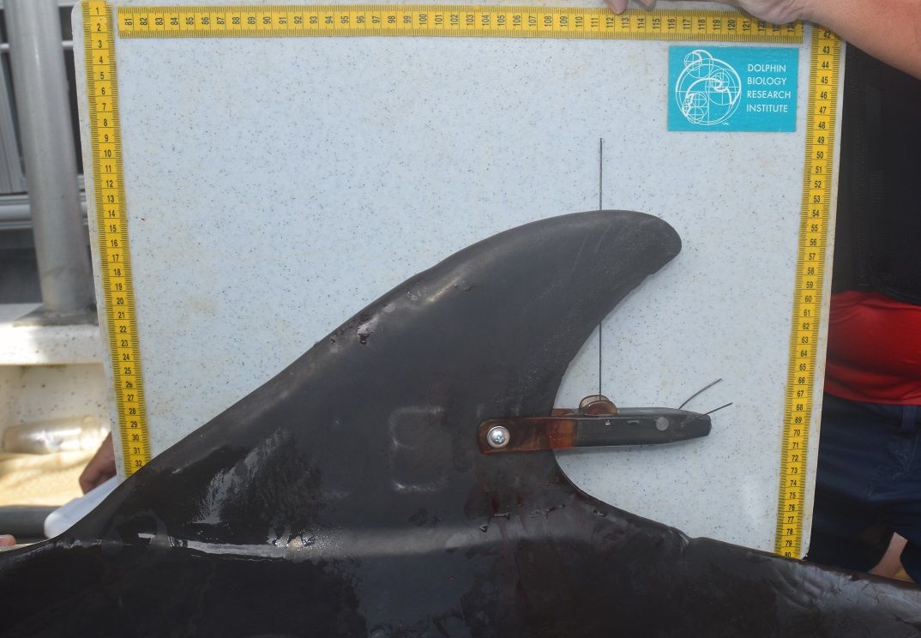

**Figure 1. A SPOT-F-368A, single-point finmount Fastloc® GPS tags (Wildlife Computers, Redmond, WA) deployed on F264, a Sarasota Bay resident bottlenose dolphin. The vertical antenna is for ARGOS transmissions, while the two trailing antennas are for acquiring Fastloc® fixes.**

*Focal Animal Sampling and Follow-up Monitoring*

Focal-animal sampling of each dolphin was conducted in the days immediately following tagging (Altman et al. 1974, Mann 1999) to both assess the health and behavior of the tagged individuals post-release, and to obtain estimates of the dolphin’s true locations for comparison with the locations acquired via Fastloc GPS. Focal individuals were located by performing daily boat-based surveys of the study area during daylight hours, which were conducted from a 5-7 m out-board powered, center-console boat. Prior to a survey, location data from recent transmissions (when available) were downloaded and assessed to guide the survey boat and increase the probability of detecting the tagged individuals in the field. When applicable, a goniometer and radio tracking gear were used in the field to help locate and identify the tagged individuals.

When a tagged dolphin was sighted, the dolphin (or dolphin group) was slowly approached by the survey boat, and basic sighting information (*e.g.,* group composition, behavior, location, environmental conditions), including images of the tagged individual and conspecifics (taken with a X camera x lens), were obtained (Wursig 1997, Hammon et al. 1990, Rosel et al. 2011). If environmental conditions were acceptable (*e.g.*, Beaufort sea state < 3) and the dolphin appeared to be healthy and behaving normal, a formal “focal follow” of the tagged individual was initiated and an attempt to estimate the animal’s distance and bearing in relation to the follow boat at each surfacing event was made. Bearing estimates were calculated with a hand held compass, while distances were estimated visually or with a Sig Sauer Kilo 2200 BDX Laser Rangefinder (7x25 mm). To minimize subjectivity in visual distance estimates, only two experienced observers provided visual distance estimates, and these observers calibrated themselves before and periodically throughout a survey by comparing known distances (obtained via range finders) to perceived distances. When a surfacing event was missed, an attempt was made to re-locate the tagged animal as soon as possible and resume the collection of location data. The focal follow continued until Fastloc fixes from that specific tag stopped transmitting (*i.e.*, every other hour based on each tag’s programming schedule as described above), conditions deteriorated such that a follow was not feasible, or individuals in the sighting group demonstrated avoidance behaviors (*e.g.,* chuffing).

After the initial post-tagging focal follows were complete, the tagged dolphins were monitored as part of monthly population monitoring surveys conducted in the region (Wells et al. 2014). If a tagged dolphin was sighted, basic information about the health and behavior of the individual was recorded, and images of the individual and tag were taken for inspection of bio-fouling, entanglement, or physical tag failure.

*Location Processing*

Fastloc GPS locations were processed using the Locsolve software within the Wildlife Computers Data Portal. Locsolve will attempt to converge the satellite pseudo-ranges that were transmitted from the tag into a single point on the surface of the earth (a lat/long estimate). The current version of Locsolve reports the residual from the convergence calculation, along with information about the satellites used to estimate the location (how many were used, how many were considered bad etc.).

Talk about the two location processing versions.

*Accuracy Analysis*

Tag data were downloaded from Wildlife Computer’s Data Portal after location processing was complete (ARGOS, WC?). Recorded times on the tags were corrected using each tags reported time offset values and adjusted to represent local time (GMT – 4 hours) for comparison with the focal follow data. Times were manually compared to times when the tagged dolphins were reported to surface during the focal follows. Any GPS records that were within 2 minutes of a focal follow surfacing observation of the tagged individual that included a distance and bearing estimate were identified as a 'snap' (*i.e.*, a matched record) for further analyses.

Dolphin locations during snaps were estimated using the *destPoint* function from the geosphere package (Hijmans, 2019) in R, Version 3.6.2 (R Core Team, 2019). This was accomplished by assuming the dolphin was located at the range and bearing estimate recorded from the focal follow boat at the time of each respective surfacing (note: five distances were estimated from a range finder, 49 were estimated visually). The focal follow boat’s location at each respective surfacing was subsequently obtained using a handheld GPS (GPSMAP® 78, GPSMap® 76CX or GPS MAP® 78sc), which recorded locations every 2-10 seconds. Location data from the time recorded by the GPS that was closest to the time of each observed surfacing was used to represent the location of the focal follow boat and thus the location of the dolphin at the observed surfacing. All handheld GPS times were within five seconds of the recorded dolphin surfacing times median, mean ± SD [range] seconds between observed surfacing events and handheld GPS records was 2.0, 1.98 ± 1.45 [0 – 5] seconds). Dolphin, Tag, and focal follow locations were projected to WGS84 using the *raster* package (Hijams, 2020) in R, Version 3.6.2 (R Core Team, 2019).

Accuracy of the GPS locations recorded by the tag and calculated using the two different LocSolve processing systems were determined by calculating the distance between the two LocSolve solutions and the estimated location of the dolphin with the *pointdistance* function from the *raster* package (Hijmans, 2020) in R, Version 3.6.2 (R Core Team, 2019). All statistics are reported as median (mean) ± SD [range].

**Results**

*Focal Follow Observations*

Tagged dolphins were followed intermittently during seven days post tagging for a total of 8:27, 6:34, and 9:39 focal follow hours for PTT IDs 179062, 179063, and 197064, respectively. All individuals appeared to be behaving normally and to be in good health. Focal follow observations resulted in 59 snaps where we have visual observations of the tagged dolphin's location within two minutes of a transmitted GPS location (179062 = 16 snaps, 179063 = 23 snaps, 179064 = 20 snaps). However, five records did not have location data available, leaving 54 snaps available for analysis (179062 = 13 snaps, 179063 = 21 snaps, 179064 = 20 snaps). Visual estimates of dolphin locations during snaps were made from within a distance of 50 (57.39) ± 48.72 [7 - 300] m from the focal follow boat. Dolphin surfacing times during snaps were recorded as being within 6 (21.31) ± 28.76 [0 – 103] seconds from the reported tag times.

*Performance of LocSolve Solutions*

Snaps were processed with the two LocSolve processing systems and good quality locations (*i.e.*, generated using ≥ 5 satellites and having residual values ≤ 35) were analyzed for accuracy. The number of good quality locations for each PTT ID and each LocSolve processing system differed due to the way these systems process locations (Figure 2); LocSolve Version 2 resulted in more good quality records (N = 15, 27.78%) than LocSolve Version 1 (N = 29, 53.70%). This was partially explained by LocSolve Version 2 using more satellites than LocSolve Version 1 (5 (5.19) ± 1.37 [4 – 8] and 4 (4.59) ± 1.04 [4 – 8] satellites used, receptively), and typically having lower residual values (3.83 (5.53) ± 4.94 [0.21 – 22.60] and 1.55 (19.8) ± 51.1 [0.1 – 257] residual values for Version 2 and 1, respectively). All of the locations considered to be good quality records using LocSolve Version 1 were also considered to be good quality locations with LocSolve Version 2; however, some of the locations considered to be good quality records using LocSolve Version 2 were considered to be poor quality with LocSolve Version 1.

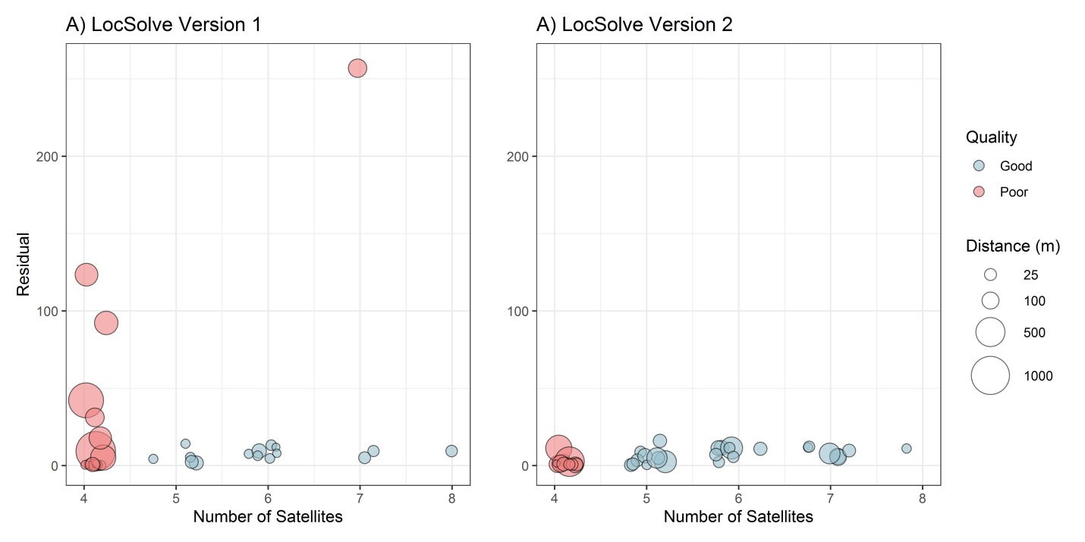

**Figure 2. The number of satellites and residual values resulting from the two LocSolve processing systems, color coded to identify the quality of the record (assuming good quality records used ≥ 5 satellites and had a residual value ≤ 35). The size of the circle represents the estimated distance between the location reported by tag’s GPS and the estimated location of the dolphin. Note: points are jittered along the x-axis within bins representing the number of satellites.**

*Accuracy of GPS Locations*

The distances between the tagged dolphin’s estimated location and the good quality GPS locations transmitted by the tag and processed using the two LocSolve processing systems are presented in Table 2. Locations processed using LocSolve Version 1 were 38.34 (81.41) ± 82.18 [7.36 - 265.32] m from the location used to represent the dolphin, while locations processed using LocSolve Version 2 were 35.98 (63.36) ± 65.60 [6.61 - 233.29] m from the location used to represent the dolphin. These distances, however, increased with increased time between the GPS time reported by the tag and the time used to estimate the dolphin’s true location (Figure 3). Median distances between the location reported by tag’s GPS with LocSolve Versions 1 and 2 and the estimated dolphin locations were < 24 m and < 29 m when the temporal lag between the tag time and the boat’s GPS time or the observed dolphin surfacing time was less than 10 seconds, respectively (Table 3). These distances decreased even further to < 20 m when the time reported by the tag and the boat’s GPS time or the observed dolphin surfacing time was less than 5 seconds and GPS locations were processed using LocSolve Version 2 (Table 3).

**Table 2. Number of snaps with location data, number (and percent) of good quality records, and median (mean) ± SD [range] distances (m) between observed tagged dolphin locations and the tag’s corresponding good quality GPS locations processed using the two LocSolve processing systems.**

|  |  |  |  |  |
| --- | --- | --- | --- | --- |
| LocSolve processing system | PTT | Number of Snaps | Number (%)  of good quality records | Median (mean) ± SD [range] distance (m) of good quality records |
| Version 1 | 179062 | 13 | 4 (30.77%) | 41.66 (86.28) ± 104.02 [21.83 - 240.00] |
|  | 179063 | 21 | 2 (9.52%) | 66.70 (67.70) ± 45.06 [34.83 - 98.56] |
|  | 179064 | 20 | 9 (45.00%) | 33.84 (82.51) ± 86.26 [7.36 - 265.32] |
|  | Total | 54 | 15 (27.78%) | 38.34 (81.41) ± 82.18 [7.36 - 265.32] |
| Version 2 | 179062 | 13 | 5 (38.46 %) | 40.63 (71.80) ± 92.72 [6.61 - 233.29] |
|  | 179063 | 21 | 8 (38.10%) | 33.97 (43.16) ± 29.98 [7.64 - 104.30] |
|  | 179064 | 20 | 16 (80.00%) | 36.14 (70.83) ± 70.85 [6.68 - 231.35] |
|  | Total | 54 | 29 (53.70%) | 35.98 (63.36) ± 65.60 [6.61 - 233.29] |

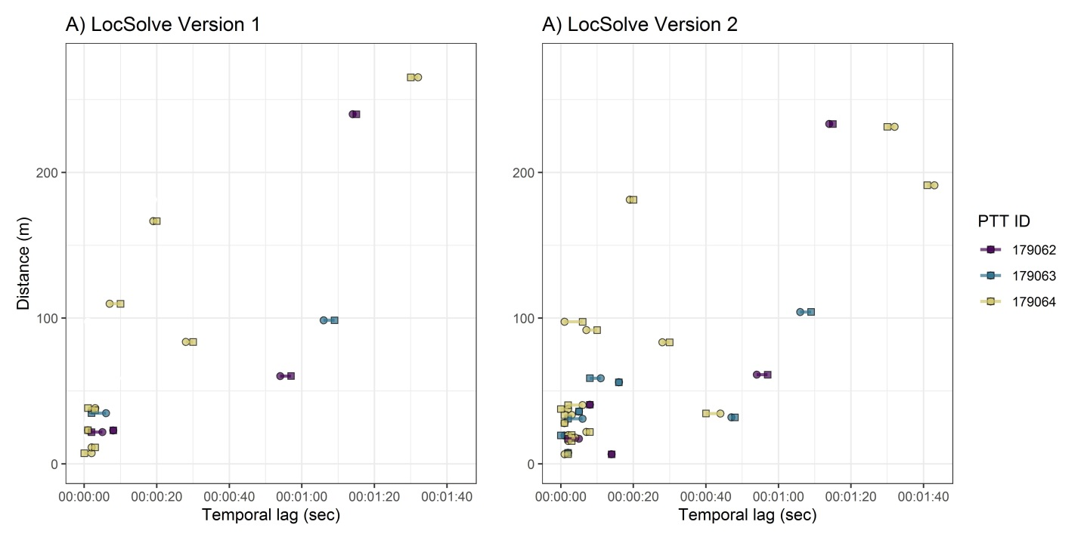

**Figure 3. Distance between the tag’s GPS location and the dolphins estimated location as a function of the temporal lag between the time reported with the GPS location and the time used to estimate the dolphin’s true location given the dolphin’s observed surfacing time (circles) or the time recorded by the focal follow boat’s GPS (squares). Horizontal lines link the these latter two times.**

**Table X. Comparing between using the tag time versus the boat’s GPS time or the recorded surface time.**

|  |  |  |  |
| --- | --- | --- | --- |
| LocSolve solution | Time used for dolphin location | Difference between tag time and  time used for dolphin location | |
| 10 sec | 5 sec |
| Version 1 | Focal Follow Boat GPS Time | 23.11 (34.06) ± 30.41 [7.36 – 109.89]  N = 9 | 23.11 (23.40) ± 14.20 [7.36 – 38.34]  N = 5 |
| Version 1 | Dolphin Surfacing  Time | 23.05 (24.58) ± 11.52 [7.36 – 38.34]  N = 8 | 23.11 (24.8) ± 12.42 [7.36 – 38.34]  N = 7 |
| Version 2 | Focal Follow Boat  GPS Time | 28.03 (33.13) ± 25.48 [6.68 – 97.46]  N = 17 | 19.67 (28.42) ± 26.29 [6.68 – 97.46]  N = 10 |
| Version 2 | Dolphin Surfacing  Time | 28.03 (33.19) ± 21.70 [6.68 – 97.46]  N = 17 | 19.67 (22.94) ± 11.09 [6.68 – 40.35]  N = 12 |

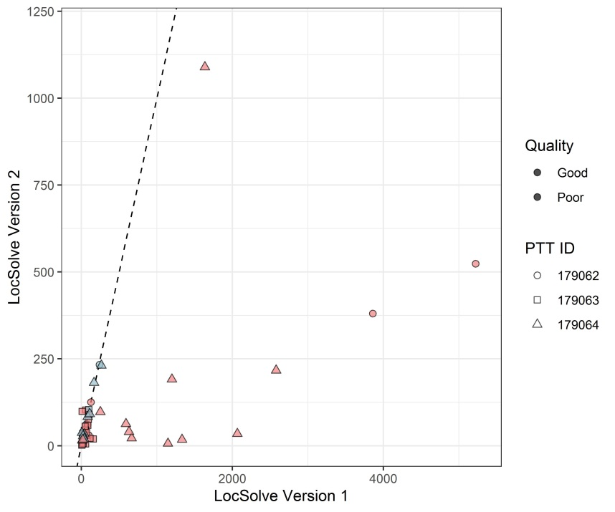

**Figure X. Estimated distances from the dolphin to the tag’s GPS by the two LocSolve Solutions. The dashed line represents the one-to-one line, meaning a point on that line had the same distance calculated from both LocSolve solutions. If a point is under the line, LocSolve Version 1 …. Need to figure out how to say this**

*Tag Performance and Follow-up Monitoring*

Tags transmitted data for 67 to 130 days and remained on the dolphins between 67 and 181 days (Table 1). Continued monitoring of the dolphins in the months after tagging revealed that algal growth (biofouling) on the tags, particularly on the tag’s sensors, hindered tag performance In fact, GPS locations were only transmitted on 37, 26, and 21 unique days for tags 179062, 179063, and 179064, respectively. This represented 28.46%, 38.81%, and 24.14% of the duration the tags were transmitting messages and data (Table X). Monitoring also revealed a stress point in the tag design as one tag was observed with the tag body detached from the tag wings on 9 and 10 September 2019 (87 and 88 days post deployment). Entanglements were never observed on the tags and the animals continued to appear healthy and behave normally during the entire tag deployment durations.

Figure of biofouling and tag breakage?

Maybe a map of all the total sightings for each individual?

**Discussion**

Data from both LocSolve versions were more accurate when we consider tag data that was received less than 10 seconds from an observed dolphin surfacing. This is likely related to the dolphin’s movements between surfacings and the likelihood that the surfacing observed and recorded during the focal follow was the surfacing that was used to generate a location on the tag.

**Conclusion (optional)**

**Acknowledgements (optional)**

We wish to thank (anyone that helped in the field). Jonathan Crossman

Funding was provided by The Animals, Research, and Conservation Committee of the Chicago Zoological Society’s (CZS) Women’s Board,

Tagging and behavioral observations were conducted under Permit.

**Authors’ contributions**

**Data Availability**

**References**

Altmann, J. 1974. Observational study of behavior sampling methods. Behaviour 49:227–267.

Barratclough, A., Wells, R.S., Schwacke, L.H., Rowles, T.K., Gomez, F.M., Fauquier, D.A., Sweeney, J.C., Townsend, F.I., Hansen, L.J., Zolman, E.S. and Balmer, B.C., 2019. Health Assessments of Common Bottlenose Dolphins (Tursiops truncatus): Past, Present, and Potential Conservation Applications. Frontiers in Veterinary Science, 6.

Hijmans, R. (2019). geosphere: Spherical Trigonometry. R package version 1.5-10. https://CRAN.R-project.org/package=geosphere

Hijmans, R. (2020). raster: Geographic Data Analysis and Modeling. R package version 3.0-12. <https://CRAN.R-project.org/package=raster>

Mann, J. 1999. Behavioral sampling methods for cetaceans: A review and critique. Marine Mammal Science 15:102–122.

Pebesma, E., 2018. Simple Features for R: Standardized Support for Spatial Vector Data. The R Journal 10 (1), 439-446, <https://doi.org/10.32614/RJ-2018-009>

R Core Team (2019). R: A language and environment for statistical computing. R Foundation for Statistical Computing, Vienna, Austria. URL https://www.R-project.org/.

Wells, R. S., Fougeres, E. M., Cooper, A. G., Stevens, R. O., Brodsky, M., Lingenfelser, R., Dold, C., & Douglas, D. C. (2013). Movements and dive patterns of short-finned pilot whales (Globicephala macrorhynchus) released from a mass stranding in the Florida Keys. Aquatic Mammals, 39(1), 61-72. https://doi-org.proxy.lib.duke.edu/10.1578/AM.39.1.2013.61

Wells, Randall S. "Social structure and life history of bottlenose dolphins near Sarasota Bay, Florida: insights from four decades and five generations." In Primates and cetaceans, pp. 149-172. Springer, Tokyo, 2014.

**Figures and tables**

**Appendix**

Table . Handheld GPS information

|  |  |  |  |
| --- | --- | --- | --- |
| Date | boat | GPS Unit | Sampling interval (sec) |
| 6/5/2019 | Naia | GPSMap76CX | 2 |
| 6/6/2019 | Bob | GPSMAP 78 | 10 |
| 6/6/2019 | Naia | GPSMap76CX | 5 |
| 6/10/2019 | Fregata | GPSMAP 78sc | 10 |
| 6/11/2019 | Fregata | GPSMAP 78sc | 10 |
| 6/12/2019 | Fregata | GPSMAP 78sc | 10 |
| 6/13/2019 | Fregata | GPSMAP 78sc | 10 |
| 6/14/2019 | Fregata | GPSMAP 78sc | 10 |

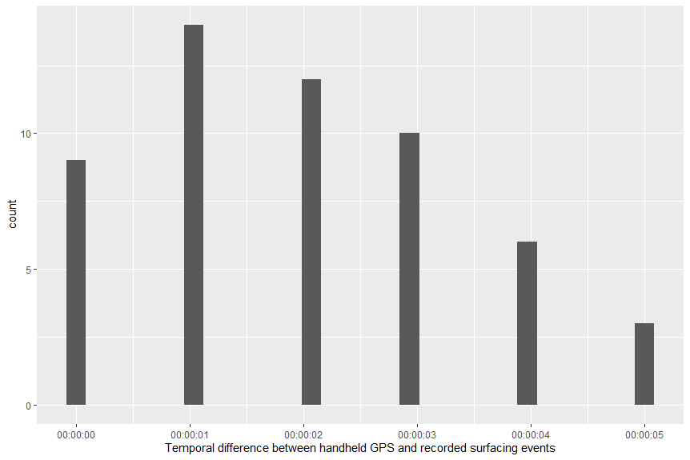

**Table: transmission scheduled during focal follow survey says**

